Twilight Zone Crossover Assignment
Chrissy Guest, Ithaca College

This assignment is given at the start of the semester with the idea that in class lab exercises and lectures will assist students in each step of the project assignment. Additional readings and in class viewings are assigned to strengthen the learning outcomes of this assignment. Every element of this assignment, lectures, labs, library support and viewings are accessed through an online delivery system, Sakai, allowing students with different learning styles and accommodations to be fully supported as they work to complete the project.

This is the layout design I’ve created to offer the assignment:
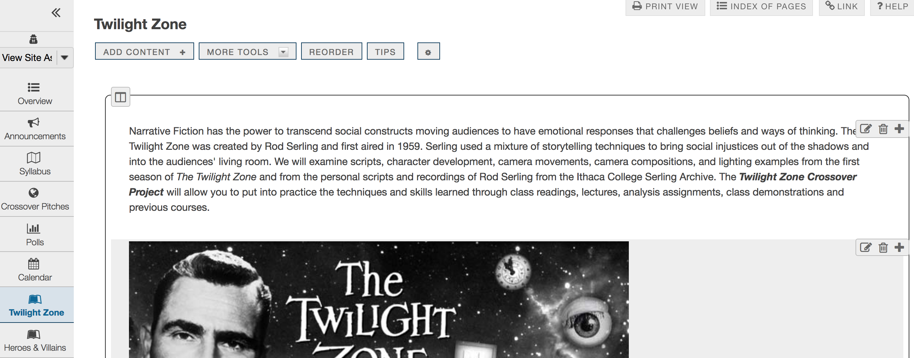
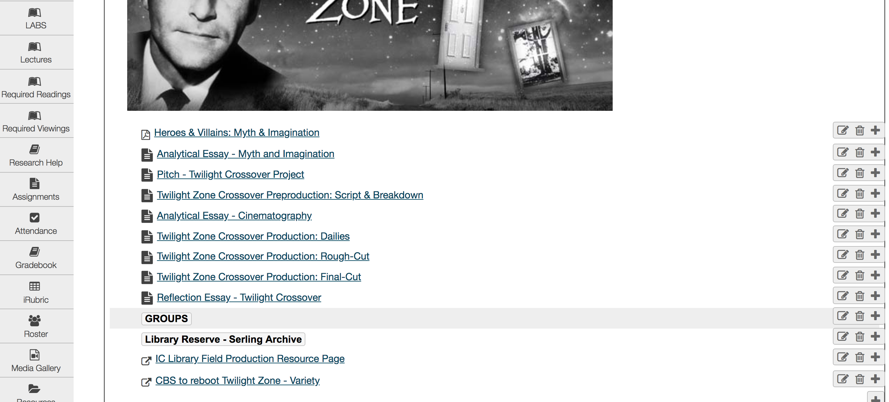

All assignment due dates are provided on the Syllabus. The following pages are the step by step instructions for each part of the assignment:

Twilight Zone Crossover Assignment Essay 1

Instructions
Myth and Imagination
Fiction Field 1: Analytical Essay
Prof. Chrissy Guest
In a 2-4-page essay examine the journey of a hero or of a villain through analysis of a television series. (Use a series from the required viewing list) In Heroes and Villains: Myth and Imagination, author Mike Alsford challenges us to consider our contemporary values and attitudes, and the principles with which we navigate our way through life. Select from a television series a hero or villain then observe the first episode and the final episode of the last season, preferably a series that spans more than one season, before answering the following:
1. How does your hero or villain transform through the series? (Consider the work of psychoanalyst, Carl Jung) How does the hero’s values and attitude challenge your own?
2. What is your hero’s system of values? How is the mode of behavior for their world established? Use evidence from you reading to support your claims.

Essay Formatting Requirements:
MLA citation should include the television series observed and reference the text Heroes and Villains by Mike Alsford.
Your Name Here (Left Justified)
Professor Guest (Left Justified)
Television Production & Direction (Left Justified)
Date (Left Justified)
Title of Paper (Centered)
Length | Spacing | Font | Font Size | Citation
2-4 page | 1.5 | Times Roman | 12 point | MLA
Submission Labeling: First Initial Last Name_FF1_Essay1.docx

Twilight Zone Crossover Assignment: Pitch

Instructions
The Pitch
This assignment is part of the Twilight Crossover Project. Individually prepare your story idea pitch. The pitch is the start of pre-production. Once the story pitch is accepted the script, if not already written, is written and the project is “green lit”. This pitch will be presented to the class for group project consideration.
Part 1- Log Line
The Log Line should be one to two sentences, which includes your protagonist, central conflict and/or antagonist, and genre. For further writing assistance and examples visit: CLICK HERE
(SUBMIT on SAKAI)
Part 2- Elevator Pitch
The elevator pitch is a paragraph that summarizes the beginning, middle and end of your script (Story). You do not want to give away the ending of your story only allude to it. The elevator pitch expands the log line giving more detail, but still doing so quickly and precisely. (SUBMIT on SAKAI)
Part 3- Presentation Pitch
You will present the pitch in class. You will have 2 minutes to present your pitch. Practice your pitch before presenting and time yourself. (You may uses visual aids in the form of slides. If using slides, please attach to your sakai submission)

Twilight Zone Crossover Assignment: Script & Breakdown

Instructions
Each member of the group should contribute to the writing process and script breakdown.
THE SCRIPT
Working in groups of 4 create a short 2-3 minute webisode based off a background character featured in an original Twilight Zone episode. The group will develop an overlapping story using the background character, bringing to life that character’s wants and needs. Rod Serling used science fiction to tell stories with social justice themes, this should remain evident in the new character’s story. The Rod Serling archives will be used for researching the work and techniques created by Serling. The finished script will be 3-4 pages in length using proper screenplay formatting. The focus should be on narrative storytelling using the visual medium.
THE BREAKDOWN
Using the example of a script breakdown in your textbook, Producing and Directing the Short Film and Video, pages 45-51. This is an important part of preproduction and is used by the producers and Assistant Director to budget and schedule the production. This breakdown will provide each production department with the key items required for production. This is essential for production design. (Use the attached worksheet to complete your project's breakdown)

Additional resources for assignment
- SCRIPT BREAKDOWN SHEET.pdf ( 58 KB; Feb 6, 2019 8:48 am )
- Script Breakdown Reading_TCFPHandbook.pdf

Twilight Zone Crossover Assignment: Dailies

Instructions
PRODUCTION: DAILIES
Submit your group's project dailies for review through Vimeo. Provide the LINK in the submission window along with a list of group members. Dailies are uncut, circle takes (best takes) from your production to date. At this point in the production your group should have work to show.
Combine your takes into one sequence in premiere export that sequence using settings Format: H.264 & Preset: Vimeo 1080 HD
Make Sure to Label your file for Vimeo using SCRIPT TITLE_Dailies_FF1

Twilight Zone Crossover Assignment: Rough Cut

Instructions
Submit your group’s project rough-cut Vimeo Link for in class critique. Adobe Premiere export that sequence using settings Format: H.264 & Preset: Vimeo 1080 HD.
Make Sure to Label your file for Vimeo using SCRIPT TITLE_RoughCut_FF1

Twilight Zone Crossover Assignment: Final Cut

Instructions
Submit your final Twilight Zone Crossover Project LINK and the list of your group members. You are required to bring your final cut file to class on Friday (3/22/19) to be transferred to the instructor's drive for archival purposes.

Twilight Zone Crossover Assignment: Reflection Essay

Instructions
Reflection Essay
The Reflection Essay should describe your contribution to the group during preproduction, production and post production. It should cover in detail what you've learned from the project’s challenges and triumphs. Give an example of how you implemented something covered in class during the course of producing this project. Give details to support your statements.
Length | Spacing | Font | Font Size | Style
3-4 pages | 1.5 | Times Roman | 12 point | Essay

